CURRICULUM VITAE

Dr. Rashmi Singh  Assistant Professor  Deptt. of Zoology, D.V.College, Orai  E-mail: rashmirrsingh@gmail.com  Phone: +91-8826741889 | 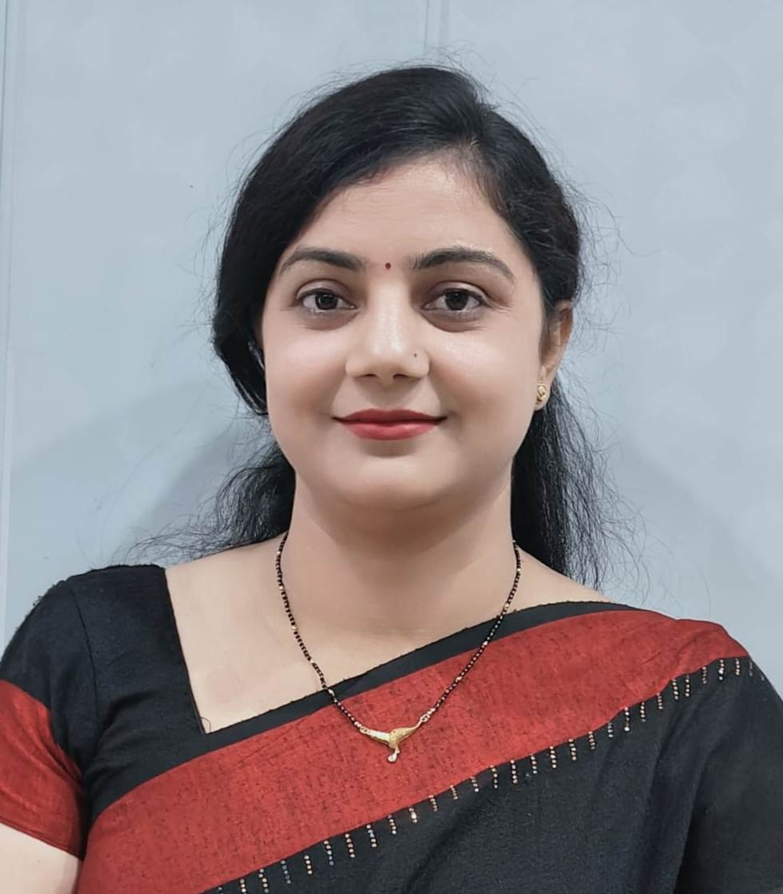

Education
2007-2011, Ph.D., Department of Zoology, University of Allahabad, India.
2004-2006, M.Sc. Department of Zoology, University of Allahabad, India.
2001-2004, B.Sc. C.M.P. Degree College, University of Allahabad, India.

Research Experience
Doctoral Research
Topic: Genetic variation in dacine (Bactrocera) fruit flies (Dacinae: Tephritidae: Diptera)
“Bactrocera fruit flies belong to the family Tephritidae are biologically interesting and economically important group of order Diptera. Tephritidae fruit flies like B. cucurbitae, B. dorsalis, B. zonata and B. diversus are widely distributed throughout the world. Larvae of fruit flies infest and damage a wide range of fruits and vegetables such as mango, peach, guava, muskmelon, gourds and pumpkin etc. B. cucurbitae is known to cause over 50% of the damage to the cucurbit vegetables and make them inedible and unmarketable. It is very interesting area to the researchers to study the biology and control of these flies using insecticides. There has been a little work done on the biology and genetic control of tephritid flies in India, which necessitates an in depth understanding of the genetic mechanism of these flies. Our aim was to be establishing a phylogenetic relationship using allozyme and RAPD-PCR techniques among different species of Bactrocera flies.”
- Successfully established the colonies of fruit flies at 26±1⁰c.
- Studied the Enzyme staining patterns using Polyacrylamide Gel Electrophoresis and different enzyme staining protocols.
- Successfully extracted and quantified genomic DNA.
- Demonstrated DNA amplification and polymerisation using a BIORAD thermal cycler.
- Studied DNA electrophoresis banding pattern run on 1.5% Agarose gel.
- The approximate Molecular Weight of the Amplicons were determined by comparison with bands for DNA Ruler with the help of Biovis V4 1D Gel Analysis Software.
- Successfully Data Matrix was prepared, Average Heterozygosity, Nei’s Genetic Identity and Distance were calculated by using Tools For Population Genetic Analysis Software (TFPGA).
- Worked on Brucellosis Disease, it’s Seroprevalence, KAP Survey and Vaccination.
- Studied Pancreatitis Disease in Human.

Ph.D. Supervision:
- Co-Supervision of Ph.D. Scholar Ms. Shreyasi Niranjan, (2022-2023) topic entitled on “Biodiversity of Zooplankton Communities in Three Ponds of Jalaun District, U.P. India”.

Teaching Experience:

- Working as an Assistant Professor (Permanent) in the Department of Zoology at Dayanand Vedic College affiliated to Bundelkhand University since 27.05.2019 to till date.
- Worked as an Assistant Professor (ad-hoc) in the Department of Zoology at Shivaji College, University of Delhi from January 2015 to 2019.
- Worked as a Guest Lecturer in the Department of Zoology at Hindu College, University of Delhi, 2013-2014.
- Worked as a Guest Lecturer in the Department of Zoology at Sri Aurobindo College, University of Delhi, August 2013-Dec. 2014.
- Worked as an Assistant Professor (ad-hoc) in the Department of Zoology, Acharya Narendra Dev College, University of Delhi, July 2012- June 2013.
- Worked as a Guest Lecturer in the University of Allahabad, 2010-2012.
- Subject Taught: Chordata, Non-Chordata, Genetics, Cytogenetics, Evolutionary Biology, Molecular biology, Animal Physiology, Developmental Biology, Ecology, Biochemistry, Animal Biotechnology, Cell Biology, Environmental Sciences, Research and Methodology, Introduction to Medical Diagnostics, Immunology, Sericulture, Apiculture, Aquaculture and Fish keeping (Theory and Practical).

Research Project:

- Worked as Principal Investigator in an Innovation project of Delhi University granted by UGC on “A dried blood spot collection study for detection of Brucellosis in Bovine population of India: an ELISA based system specific to Omp25 and Omp28 proteins of Brucella abortus (2015-2016)”
SHC-308 (500,000/- Rupees).

Publications

Books (Chapter in Book)
- Rashmi singh and Ankita Raj, Madhumakhi palan vyasaya: Avsar avam chunautiyan, (2023), Bhartiya samajik pariprekshya mein nari, p.n. 52, ISBN: 978-93-92516-60-3, University Publication, Delhi-110002.
- Rashtriya Shiksha Neeti – Rozgar ke naye avasar.
Articles:
- Singh Rashmi, N. Bajpai and R.R. Tewari, Genetic characterization of Bactrocera (Dacus) flies (Diptera: Tephritidae) based on RAPD- PCR, 2011, International Journal of Pharma and Biosciences, 2: 498-503. ISSN: 0975-6299.
- Rashmi Singh, Akanksha Singh, Uma R. Agrawal and R.R. Tewari, Allozyme analysis for assessing genetic variation in the species Bactrocera diversa and B. zonata (Dacinae: Tephritidae), 2011, International Journal of Pharma and Biosciences, 2: 193-199, ISSN- 0975-6299.
- Saumya Srivastava, Rashmi Singh and R.R. Tewari, Temporal variation among populations of house fly Musca domestica (Diptera: Muscidae), International Journal of Pharma and Biosciences, 2011, 3: 254-260, ISSN- 0975-6299.
- Rashmi Singh and R.R. Tewari, Genetic variation among fruit flies of the genus Bactrocera (Diptera: Tephritidae: Dacinae), 2012, Proceedings of the National Academy of Sciences, India Section B: Biological Sciences DOI 10. 1007/s40011-012-0023-3, ISSN- 0369-8211.
- Akanksha Singh, Rashmi Singh, Uma R. Agrawal and R.R. Tewari, Stress response of polytene chromosomes of Sarcophaga ruficornis (Fab.) (Sarcophagidae: Diptera) to lead nitrate, 2012, International Journal of Pharma and Biosciences, 3(3)B: 578-583. ISSN-0975-6299.
- Rashmi Singh and Akanksha Singh, Genetic variation in two species of fruit flies of the genus Bactrocera (Dacinae: Tephritidae: Diptera), 2013, International Journal of Pharma and Biosciences, 4(2): 617-623, ISSN-0975-6299.
- Akanksha Singh and Rashmi Singh, Induction of a puffing by chromium nitrate treatment in polytene chromosomes of pupal food pad of Sarcophaga ruficornis (Fab.) (Sarcophagidae: Diptera), 2015, Journal of Basic Sciences, 2(1): 1-5. ISSN- 2554-1931.
- Akanksha Singh and Rashmi Singh, Genotoxic effects of Cadmium Chloride on polytene chromosomes of Sarcophaga ruficornis (Fab.) (Sarcophagidae: Diptera), 2015, International Journal of Development Research, 5(9): 5458-5462. ISSN- 2230-9926.
- Akanksha Singh and Rashmi Singh, Study of cypermethrin induced puff in Sarcophaga ruficornis (Fab.) (Sarcophagidae: Diptera),2018, Int J Pharma and Bio Sciences; 9(1): (B) 77-82. ISSN: 0975-6299.
- Nimita Kant, Parul Kulshreshtha, Rashmi Singh, Anuradha Mal, Shashikant Kumar, Mohit Tehlan, Amita Dwivedi, Rinkle Mehra, Riya Ahuja, Shilpa Kausik and Paritosh Ahmed. Knowledge and prevalence of Brucellosis: a case study of NOIDA, a National Capital Region of India. 2018. The Delhi University Journal of Undergraduate Research and Innovation (DUJURI), 4:1, 43-49. ISSN: 2395-2334.
- Kant et al., A study to identify the practices of the buffalo keepers which inadvertently lead to the spread of brucellosis in Delhi. BMC Veterinary Research (2018), 14: 329. ISSN: 17466148.
- Rashmi Singh, Deeksha Marwari and Akanksha Singh. A Study of Knowledge, Attitude and Practices associated to Brucellosis among cattle keepers in Uttar Pradesh, India, Biological forum (2023), 15(4): 434-439. ISSN: 2249-3239.
- Rashmi Singh, Shreyasi Niranjan and Sasya Nagar. " Physico-Chemical Characteristics of a Fresh Water Pond of Orai, U. P., India", Uttar Pradesh Journal o Zoology (2023), 44: 83-93, ISSN: 0256-971X.
- Rashmi Singh and Akanksha Singh. A Study of Brucellosis in Cattles and Humans, Vigyan Varta, (2023), 4(5): 8-10. 2582-9467.
- Rashmi Singh. Study of Pancretitis: A life threatening disease, Vigyan Varta, (2023), 4(9): 137-140.
- Rashmi Singh. Study of brucellosis in cattles’ of Uttar Pradesh, Immunology talks to public health, (2023), 13:145.
- Rashmi Singh and Nimita Kant. Maveshiyon avam manushyon me brucellosis ka adhyayan, Vigyan Garima Sindhu, under publication, ISSN: 2320-7736 (UGC-CARE listed).
- Shreyasi Niranjan, Rashmi Singh and Sasya Nagar Physico-Chemical Parameters of a Freshwater Pond in Konch Town, India", Indian Hydrobiology, under publication, ISSN: 0971-6548 (UGC-CARE listed).
- Rashmi Singh and Nimita Kant. Maveshiyon aur manushyon mein Brucellosis ka adhdhyayan Vigyan Garima Sindhu. 2024.
- Food Security
Chair:
- Rashmi Singh co-chaired a session on COVD-19 pandemic and challenges; Sustainability, Future earth, and humanities: opportunities and Challenges. International Geographic Union Thematic Conference, 2022, CUH 24-25 Nov. 2022.
- Rashmi Singh co-chaired a session on International Conference on ‘One Earth, One Family, One Future: Navigating human Rights through the lenses of Vasudhaiva Kutumbakam’ organized by Human Right Studies Program, School of International studies, Jawaharlal Nehru university, 28-29 March, 2024.

Paper (Oral & poster) Presented:
- Rashmi Singh and R.R. Tewari: Genetic variation in fruit fly Dacus cucurbitae (Diptera:Tephritidae). 78th annual session of National Academy of Sciences, India- “Novel Approaches for Biomedical Research” Punjab University. Chandigarh, (Nov.21-23, 2008).
- Singh Rashmi, Neelam Bajpai and Raghav Ram Tewari: Genetic relationship between two Species of fruit flies of the genus Dacus (Dacinae: Tephritidae: Diptera) Proc. XXXIII All India Cell Biology Conference (AICBC) and International Workshop on “Cell Cycle Regulation” School of life sciences, University of Hyderabad, Hyderabad (Dec.10-13, 2009).
- Rashmi Singh and Raghav Ram Tewari: Genetic variation in fruit fly Dacus cucurbitae (Dacinae :Tephritidae: Diptera). 79th annual session of National Academy of Sciences, India- “Science and Technology and the Young (Career, Creativity, Excitement)” University of Kolkata in collaboration with Ramkrishna Mission Institute of Culture, (Dec.14- 16, 2009).
- Rashmi Singh and Raghav Ram Tewari: Enzymatic variability in fruit fly Dacus dorsalis (Diptera: Tephritidae: Dacinae) National Conference on emerging trends in Biochemistry and satellite symposium of the Academy of Environmental Biology, Department Biochemistry University of Allahabad, Allahabad, (Jan. 23-24, 2010).
- Rashmi Singh, Neelam Bajpai and Nidhi Mishra. Genetic Characterization of Bactrocera cucurbitae and Bactrocera dorsalis (Diptera: Tephritidae) with RAPD-PCR and Allozymes. 80th annual session of National Academy of Sciences, India, “Climate Change- Reasearch Awareness and Capacity Building” Jaipur National University, Jaipur, (Dec. 2-4, 2010).
- Nidhi Mishra and Rashmi Singh. Nuclear anomalies induced by temperature stress in housefly Musca domestica (Diptera: Muscidae). 80th annual session of National Academy of Sciences, India, “Climate Change- Reasearch Awareness and Capacity Building” Jaipur National University, Jaipur, (Dec. 2-4, 2010).
- Rashmi Singh and Nidhi Mishra. Genetic characterization of fruit fly Dacus dorsalis (Diptera: Tephritidae). 98th Indian Science Congress, Animal, Veterinary and Fishery Sciences, SRM University, Chennai. (Jan. 3-7, 2011).
- Nidhi Mishra, Rashmi Singh and R.R. Tewari. Testing of genotoxic potential of mercury in housefly Musca domestica (Diptera: Muscidae) by using cytogenetic end points. 98th Indian Science Congress, Animal, Veterinary and Fishery Sciences, SRM University, Chennai, (Jan. 3-7, 2011).
- Akanksha Singh, Rashmi Singh and R.R. Tewari. Chromosomal response to Chromium in Sarcophaga ruficornis (Fab.) (Sarcophagidae: Diptera) 22nd All India Congress of Zoology and National Seminar on Recent advances in Biological Sciences: Biodiversity and Human Welfare, December 29-31, 2011.
- Rashmi Singh and Akanksha Singh. Genotoxic effect of lead nitrate on polytene chromosome and nucleolus of Sarcophaga ruficornis. National seminar on water and air quality in urban ecosystem, Shivaji college, New Delhi, 22 March 2016. (awarded Second best Prize in poster presentation)
- Rashmi Singh, Nimita kant, Parul Kulshreshtha, Anuradha Mal, Seroprevalence survey of Brucellosis in buffalo population of Delhi-NCR region. National symposium on Trends in research and innovations in life sciences at undergraduate level, DDU, University of Delhi, 30 March, 2016.
- Rashmi Singh, Nimita kant, Parul Kulshreshtha, Anuradha Mal, Seroprevalence survey of Brucellosis in buffalo population of Delhi-NCR region. Brucellosis 2016 International research conference, NASC, New Delhi, 17-19 November 2016.
- Nimita Kant, Rashmi Singh and Akanksha Singh, Effect of insecticide on polytene chromosomes of Sarcophaga ruficornis (Fab.), On role of microbe-plant-animal interactions in human health, INSCR International conference (IIC-2017), University of Delhi, 26-28 September 2017.
- Rashmi Singh, Challenges in health sector of India after COVD-19 pandemic, Sustainability, Future earth, and humanities: opportunities and Challenges. International Geographic Union Thematic Conference, 2022, CUH, 24-25 Nov. 2022.
- Rashmi Singh, Threat of Brucellosis in cattles and human. National Research seminar on “Amritkal mein Bharat ke samaksh chunatiya avam avasar”. Government Tilak PG Degree College, Katni, MP, 17-18 Jan. 2023.
- Rashmi Singh, A survey of Knowledge, Attitude and Practices (KAP) of cattle keepers on brucellosis in U.P., Recent Trends & Experimental Approaches for Sustainable Development and Conservation of Biodiversity – 2023, D. B. S. College, Kanpur, U.P. (25-27 March,2023).
- Rashmi Singh, Study of brucellosis in cattles’ of Uttar Pradesh, Ponnaiyah Ramajayam Institute of Science and Technology (PRIST) Deemed to be University Thanjavur, Department of Biotechnology School of Arts and Science. (28.04.2023).
- Rashmi Singh presented paper on Biotechnology Approaches to Brucellosis Control: Implications for Foreign Policy National Conference on “Increasing Importance of Science and Technology in Foreign Policy”, Department of chemistry, Guru Ghasidas Vishwavidyalaya Bilaspur (C.G.), in collaboration with ICWA Conference, New Delhi. 20-21 Feb 2024.
- Rashmi Singh, ‘A study of genetic variation in Dipterans using Molecular Markers’ in an International Conference on ‘Multifaceted Applications of Chemical; Sciences (ICMACS-2024)’ organized by Department of Chemistry, M.L.K.P.G. College, Balrampur, U.P. in association with Global environment & Social Association (GESA), New Delhi. 30-31 March 2024.
- Rashmi Singh presented paper on Vaccination Equity: Ensuring Access as a Fundamental Human Right on International Conference on ‘One Earth, One Family, One Future: Navigating human Rights through the lenses of Vasudhaiva Kutumbakam’ organized by Human Right Studies Program, School of International studies, Jawaharlal Nehru university, 28-29 March, 2024.

Workshop Attended:
- Three day’s National Workshop on ‘Development of Herbal Products’ Organised by Department of Chemistry Guru Ghasidas Vishwavidyalaya (A Central University) Bilaspur (C.G.) in Collaboration with Technology Enabling Centre (TEC) during March 20-22, 2024.
- Seminar-cum-Workshop on “Techniques in Molecular Biology” Department of Zoology, University of Allahabad, (March 16-18, 2008).
- Seminar-cum-Workshop on “Emerging Trends in Molecular Biology” Department of Zoology, University of Allahabad, (March 23- 25, 2009).
- Resource person in INSPIRE SCIENCE CAMP, (Innovation in Science Pursuit for Inspired Research) DST Govt. of India, Shivaji College, University of Delhi, 2015, 2016, 2018.
Faculty Development Program:

- UGC Sponsored Refresher Course in the subject Information and Communication Technology (MD) from 20-01-2012 to 09-02-2012, University of Allahabad.
- 117th Orientation Program sponsored by UGC-HRDC, Jawaharlal Nehru University from 24 Feb, 2020 -16 March, 2020.
- 25th Refresher course sponsored by UGC-HRDC, Jawaharlal Nehru University in life sciences and Biotechnology from 28 -12-2020 to 09.01.2021.
- Short Term Course on NAAC documentation (6, 13, 20, 27th Feb 2024) Certificate from White code, IQAC Cluster India.
- Seminar/ Symposium attended:
- Symposium on “Molecular Approaches in Cytogenetics” Department of Zoology, University of Allahabad, (October 20-22, 2005).
- 78th annual session of National Academy of Sciences, India,”Novel approaches for Bio-Medical Research” Punjab University, Chandigarh, (Nov. 21-23, 2008).
- 80th annual session of National Academy of Sciences, India, “Climate Change- Research Awareness and Capacity Building” Jaipur National University, Jaipur, (Dec. 2-4, 2010).
- National Conference on Emerging trends in Biochemistry and satellite symposium of the Academy of Environmental Biology, Department Biochemistry University of Allahabad, Allahabad. (Jan. 23-24, 2010).
- 98th Indian Science Congress, Animal, Veterinary and Fishery Sciences SRM University, Chennai, (Jan. 3-7, 2011).
- Scientific paper writing organized by The National Academy of Science, India, (NASI) from October 22-24, 2011, at Allahabad.
- National seminar on water and air quality in urban ecosystem, Shivaji college, New Delhi, 22 March 2016.
- National symposium on Trends in research and innovations in life sciences at undergraduate level, DDU, University of Delhi, 30 March, 2016.
- Brucellosis 2016 International research conference, NASC, New Delhi, 17-19 November 2016.
- On role of microbe-plant-animal interactions in human health, INSCR International conference (IIC-2017), University of Delhi, 26-28 September 2017.
- Participated in E- summit on the theme, ‘Entrepreneurship Development through Ecotourism in Northeast India’ at Shivaji College, University of Delhi on February 14-15, 2019.
- Participated in one day workshop in National Workshop on Emerging pollution challenges on earth ecosystem – SAFAR, India’s Novel Initiative at Environmental Pollution Laboratory Department of Environmental Studies, University of Delhi, on March 26, 2019.

Seminar Organised:
- Lecture on Lifestyle disorders on 12th December 2023. "Cancer Prevention: What We Can Do." By Dr. Kumar Sandeep, AIIMS, New Delhi.
Program Organised:
- Organised a ‘Flower show program’ in college on the theme ‘Best Out of Waste’ on 01.03.2024 in Dayanand Vedic College, Orai, U.P.
Fellowships, Honours and Awards
- 2016: Won second best poster award in poster competition in National seminar on water and air quality in urban ecosystem, Shivaji college, New Delhi, 22 March 2016.
- 2011: Ph.D. (Doctorate degree), University of Allahabad, India.
- 2007-2010: Ph.D. Research Fellowship (RF) awarded by University Grants Commission (UGC), Govt. of India.
- 2007: Qualified National level entrance examination Interview for PhD programme at Department of Zoology, University of Allahabad, India.
- 2008: Qualified CSIR-NET Exam in Life Sciences to attain Eligibility for Lectureship.
- 2003: Qualified “All India Combined Entrance Test” for admission in M.Sc. In Zoology programme conducted by the University of Allahabad, Allahabad, India.
- Technical Knowledge
- Expertise in DNA Extraction, separation of DNA, PCR, RT-PCR
- Polyacrylamide gel electrophoresis: for protein and DNA analysis
- Agarose gel electrophoresis: for the detection of DNA
- Raring and maintenance of Colonies of Bactrocera fruit flies, Sarcophaga, Musca and Chrysomyia, Drosophila.
- Molecular Biology: Preparation of genomic DNA, Manipulation, recovery and resolution of DNA, Preparation of RNA from Eukaryotic organism.
- UV-Vis Spectrophotometer: DNA quantification
- PCR machine Handling
- Gel documentation software
- Sample preparation for gene sequencing
- Light Microscope handling image analysis
- Polytene chromosome preparation of many Dipteran flies
- Elisa reader handling

Personal Details
- Father’s Name: Harish Kumar Singh
- Mother’s Name: Munni Singh
- Spouse Name: Prof. Shantesh Kumar Singh
- Date of Birth: 7th April, 1983
- Place of Birth: Vil- Assaitha, Jaunpur, Uttar Pradesh, India
- Languages Known: Hindi and English
- Marital Status: Married
- Children: Two (Aarna & Avyaan)
Extra-curricular activities
- Worked as volunteer in many National and International Conferences.
- Participated in many Conferences and Departmental Scientific Quiz Competitions.
Referees
- Mrs. Nimita Kant, Associate Professor Department of Zoology, Shivaji College, University of Delhi, New Delhi, India. E-mail: nimitakant@gmail.com Contact No. +91-9871620360.
- Dr. Deepika Yadav, Associate Professor, Department of Zoology, Shivaji College, University of Delhi, New Delhi, India. E-mail: dy_277@yahoo.com Contact No. +91-9868506062.
- Dr. Monica Misra, Professor, Department of Zoology, AND College, University of Delhi, India. E-mail: monica801a@yahoo.com Contact No. +91-9560076661.

